**Project Structure Walkthrough**

**1. src/main/java**

* Contains application source code
* Key package: com.cognizant.springlearn
* Entry point: SpringLearnApplication.java

**2. src/main/resources**

* Holds application configuration files
* Examples:
  + application.properties
  + Static resources (HTML, CSS, JS) if added

**3. src/test/java**

* Contains unit and integration test classes

**4. SpringLearnApplication.java**

* Entry point of the application, defined with:

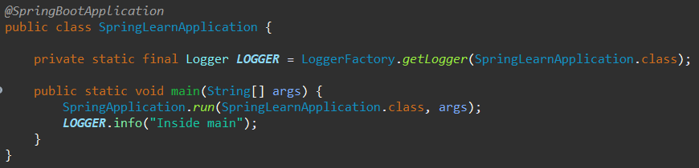**5. Purpose of @SpringBootApplication annotation:**

A convenience annotation that combines:

* @Configuration: Marks class as source of bean definitions
* @EnableAutoConfiguration: Enables Spring Boot auto-configuration
* @ComponentScan: Scans current and sub-packages for components

**6. pom.xml Explanation:**

The pom.xml (Project Object Model) file manages:

* **Dependencies**: Libraries required like Spring Web, DevTools, etc.
* **Plugins**: Tools for building/testing the project
* **Build Configuration**

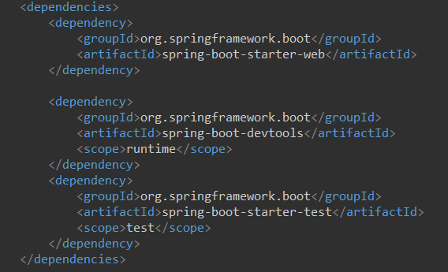

**Dependency Tree in Eclipse:**

